TAP 605- 2: Formation of dry ice from a CO₂ cylinder

You will need
- CO₂ cylinder with siphon tube
- dry ice attachment (e.g. Snowpack or Jetfreezer) or a nozzle with a small hole
- a cloth
- insulating gloves
- safety notes

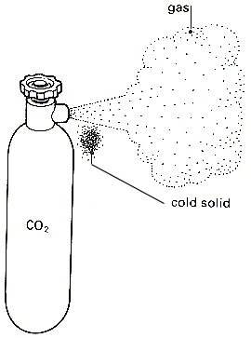

What to do:
If the carbon dioxide is released quickly through a small hole then a small quantity of dry ice may form, as illustrated above.
The quantity of dry ice is increased if a cloth is held loosely around the hole
A snowpack attachment (see below) allows the production of dry ice pellets.

Safety
Wear safety spectacles
Remember to wear insulating leather gloves when handling dry ice.
(See also CLEAPSS Laboratory Handbook section 11.2)

You have seen:
The rapid expansion of the gas produces cooling.

Practical advice

CO₂ cylinder (siphon type)

Uses
Dry ice has many uses. As well as simply watching it sublimate, you could also use it for cloud chambers, dry ice pucks, cooling thermistors and metal wire resistors in resistance experiments, and experiments related to the gas laws. Don't be tempted to get a small cylinder - it will run out too quickly.

What type of cylinder, where do I get CO₂ and what will it cost?
A CO₂ gas cylinder should be fitted with a dip tube (this is also called a ‘siphon type’ cylinder). This enables you to extract from the cylinder bottom so that you get CO₂ in its liquid form, not the vapour.
NOTE: A plain black finish to the cylinder indicates that it will supply vapour from above the liquid. A cylinder with two white stripes, diametrically opposite, indicates it has a siphon tube and is suitable for making dry ice.
A cylinder from British Oxygen will cost about £80 per year for cylinder hire and about £40 each time you need to get it filled up. (The refill charge can be reduced by having your chemistry department cylinders filled up at the same time).
If the school has its own CO₂ cylinder there will be no hire charge, but you will need to have it checked from time to time (along with fire extinguisher checks). Your local fire station or their suppliers may prove a good source for refills.

CLEAPSS leaflet PS45 Refilling CO₂ cylinders provides a list of suppliers of CO₂

A dry ice attachment for the cylinder
Dry ice can be made using an attachment that fits directly on to a carbon dioxide cylinder with a siphon tube. Section 11.2 of the CLEAPSS Laboratory Handbook explains the use of this attachment (sometimes called Snowpacks or Jetfreezers)

VWR International sells Snowpacks through its UK distributor. The version that makes 30 g pellets of dry ice is catalogue number 3285042/02

Phillip Harris sells similar products. See their catalogue, (http://www.philipharris.co.uk/ )

Safety
Wear safety spectacles
Remember to wear insulating leather gloves when handling dry ice

External references
This diagram is taken from Nuffield Revised Physics section K
The practical advice is taken from http://www.practicalphysics.org/go/Apparatus_348.html

