TAP 525-1: Change in energy: Change in mass

Calculating using Erest = mc2
These questions show you how to calculate changes in energy from changes in mass, using Einstein’s relation Erest = mc2 linking the rest energy of a particle to its mass.

Transmutation of chemical elements
The dream of the ancients was alchemy: turning base metals into gold. Although this is chemically impossible, at the end of the nineteenth century radioactivity was discovered by Henri Becquerel. When alpha and beta radiation are emitted atomic nuclei are ‘transmuted’ from one element to another. For example:
${}_{\text{92}}^{\text{238}}{}\text{uranium}→_{2}^{4}\text{alpha}+{}_{\text{90}}^{\text{234}}{}\text{thorium}\text{.}$
In 1932 using protons (hydrogen nuclei) accelerated through a potential difference of 800 000 V, two English physicists, Cockcroft and Walton, carried out the first artificial transmutation: by bombarding lithium with the protons they produced two helium nuclei:
$${}_{1}^{1}H+ _{3}^{7}\text{Li}→_{2}^{4}\text{He}+ _{2}^{4}\text{He}\text{.}$$

Change in mass
Notice that in both these reactions the mass number and charge (proton number) are conserved. Energy, however, is only conserved if you take account of changes to the rest energy – in effect of changes to the masses – of the particles.
In Cockcroft and Walton’s experiment, the masses of the particles are:

• H: 1.0073 atomic mass units
• Li: 7.0160 atomic mass units
• He: 4.0015 atomic mass units.

An atomic mass unit, symbol u, is equal to 1.6605 × 10–27 kg.
1 Show that the mass decreases in this reaction.
${}_{1}^{1}H+ _{3}^{7}\text{Li}→_{2}^{4}\text{He}+ _{2}^{4}\text{He}\text{.}$
Calculate Δm in atomic mass units and in kilograms.

Change in energy

2 The energy of the protons was 800 000 electron volts (800 keV). The lithium was in solid form so the nuclei would only have been vibrating due to thermal energy, less than an electron volt.
The reaction was captured in this photograph:

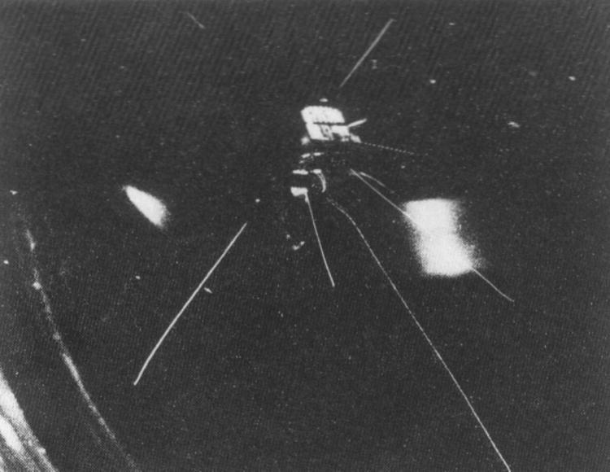

Two pairs of alpha particles, emerging in opposite directions, can be seen in the photograph.
From the range of the tracks through the cloud chamber the energy of the alpha particles was measured to be 8.5 MeV each.
Show that the total kinetic energy of the particles increases, and calculate ΔE in MeV and in joules.

3 If the increase in kinetic energy comes from the decrease in rest energy you should expect ΔE = Δmc2. Calculate the ratio of the change in kinetic energy to the change in mass ΔE/Δm in J kg–1.

4 Show that the value of the ratio ΔE/Δm is approximately consistent with the relationship ΔE = Δmc2.

The large value of c 2 (9 × 1016 J kg–1: use this value from now on in calculations) means that a small change in mass represents a vast change in rest energy. This relationship between mass and energy is why particle physicists measure masses in MeV / c2; any unit of energy divided by c2 is a unit of mass.

Creating massive particles
Energy is ‘materialised’ in matter–antimatter production. A photon of electromagnetic radiation can produce an electron and a positron. In this case, the energy of the photon vanishes and the rest energy of the particles appears. (This reaction needs to take place near to the nucleus of a heavy atom to conserve momentum but this is not going to affect your calculations here.)
In this bubble chamber photograph a photon enters from the bottom. It is uncharged and so produces no observable track. After some distance the photon disappears and produces the electron–positron pair. These two charged particles ionise the liquid in the chamber and bubbles form near the ions and are photographed.

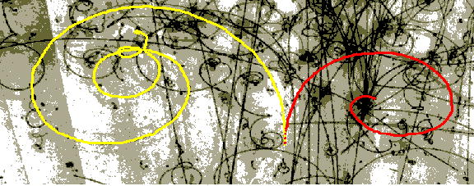

In this case the chamber is filled with liquid hydrogen mixed with liquid neon. It is held under pressure which is released just as the particles enter the chamber to encourage bubbles to form and enlarge near the ions.
5 The bubble chamber is in a magnetic field, so charged particles bend due to the force Bqv on a moving charge. How does the photograph show that the two particles have opposite charges?

6 The mass of the electron is 5.5 × 10–4 u. What is the minimum energy photon that will produce an electron–positron pair? From what part of the electromagnetic spectrum is this? (Planck constant h = 6.63 × 10–34 J Hz–1.)

Nuclear binding energy
If protons and neutrons (together known as nucleons) are bound together in a nucleus, the bound nucleus must have less energy than the nucleons of which it is made. That is, the rest energy of the nucleus must be less than the sum of the rest energies of its nucleons. In turn, this means that the mass of the nucleus must be less than the sum of the masses of its nucleons.
The simplest compound nucleus is the deuteron, the nucleus of hydrogen-2. It consists of a proton and a neutron bound together by the strong nuclear force. The masses of these particles are:

- proton: 1.0073 u
- neutron: 1.0087 u
- deuteron: 2.0136 u.

7 Calculate the difference in mass between a deuteron and one proton and one neutron.

8 Calculate the binding energy of the deuteron in J and in MeV.

9 Calculate the binding energy per nucleon of the deuteron.

10 Express the difference in mass as a percentage of the sum of the masses of the proton and neutron.

Mass change in nuclear fission
A possible reaction for the nuclear fission of uranium-235 is:
$${}_{\text{92}}^{\text{235}}{}U+ _{0}^{1}n→{}_{\text{51}}^{\text{133}}{}\text{Sb}+{}_{\text{41}}^{\text{99}}{}\text{Nb}+4_{0}^{1}n\text{.}$$
The masses of the particles are
- U-235 = 235.0439 u
- Sb-133 = 132.9152 u
- Nb-99 = 98.9116 u
- neutron (n) = 1.0087 u.

11 Show that the energy change per atom of uranium is about 200 MeV and calculate Δm/m.

Summary
Einstein's famous equation Erest = mc2 reveals a Universe that is not as simple as it seems at first sight. The mass of a particle is generally a very large part of its total energy. The existence of rest energy was not suspected until after Einstein had predicted it, because the change in mass is usually so small, because changes in energy are usually a small fraction of the rest energy. Only in nuclear reactions where Δm/m ~ 0.1% or more are you able to see the change in mass, accompanied by what appears to be a huge change in energy.

Hints
1 Compare masses of H plus Li with mass of two He nuclei.
2 Two 8.5 MeV alpha particles come out, but one 800 keV proton goes in.
3 Compare the answers to questions 1 and 2.
4 Don’t expect to get exactly the speed of light. Remember to take the square root of c²!
5 What is the difference between forces F and - F?
6 Start with the mass of an electron in atomic mass units. Convert to kilograms. Write down the mass of an electron–positron pair. Use E_{rest} = mc² to get the rest energy of the pair in joules. Then use E = hf.
7 Do this one in the same way as question 1.
8 E_{rest} = mc² again. But now use the electron charge to get to electron volts and MeV.
9 How many nucleons in a deuteron?
10 Best to take the difference as a fraction of the mass before.
11 Add up before and after masses in atomic mass units first. Don’t forget there’s one extra neutron to start with and four extra neutrons afterwards. Then convert mass changes first to joules and then to MeV.

Practical advice
These questions practise the use of the relation between rest energy and mass in various contexts: nuclear transmutation, creation of particle–antiparticle pairs, nuclear binding and nuclear fission.
You may need to select only certain groups of questions, depending on what the class has covered. Alternatively, the whole set could be used for revision.
Some of the questions make extra demands in frequent changes of units, between atomic mass units, kilograms, joules and electron volts or MeV. You may well need to give extra help here.
Note the consistent use of the term ‘rest energy’. The rest energy is treated as part of the total energy. It manifests itself in the mass of a particle. If mass is measured in kilograms and energy in joules, then the conversion is E_{rest} = mc². Remember that the mass, an invariant, is a physical property of a particle independent of frame of reference.
The questions bring out the fact that the rest energy is a very large fraction of the total energy, in many cases.

Alternative approaches
You may want to show that energies involved in everyday processes involve negligible changes in mass. The calculations of percentage change of mass in the questions here provide a starting point.

Social and human context
It is not possible to ignore the consequences for war and peace of the possibility of tapping these very large sources of energy.

Answers and worked solutions
1.
$$\text{Mass} \text{of} H \text{plus} \text{Li}=1\text{.}\text{0073} u+7\text{.}\text{0160} u=8\text{.}\text{0233} u$$
$$\text{Mass} \text{of} \text{two} \text{He}=2×4\text{.}\text{0015} u=8\text{.}\text{0030} u$$
$$\text{Difference} Δm=8\text{.}\text{0030} u−8\text{.}\text{0233} u=−0\text{.}\text{0203} u$$
So we can find the mass difference in kg:
$Δm=−0\text{.}\text{0203} u×1\text{.}\text{6605}×{\text{10}}^{−\text{27}} \text{kg}=−3\text{.}\text{3708}×{\text{10}}^{−\text{29}} \text{kg}$
2.
Increase in energy:
$$ΔE=2×8\text{.}5 \text{MeV}−0\text{.}8 \text{MeV}=\text{16}\text{.}2 \text{MeV}$$
In joules:
$ΔE=(\text{16}\text{.}2×{\text{10}}^{6} \text{eV})×(1\text{.}6×{\text{10}}^{−\text{19}} J {\text{eV}}^{−1})=2\text{.}6×{\text{10}}^{−\text{12}} J$

3.
$\frac{ΔE}{Δm}=\frac{2\text{.}\text{60}×{\text{10}}^{−\text{12}} J}{3\text{.}\text{37}×{\text{10}}^{−\text{29}} \text{kg}}=7\text{.}7×{\text{10}}^{\text{16}} J {\text{kg}}^{−1}\text{.}$
4. If ΔE = Δmc2, then c2 = 7.7 × 1016J kg–1, so c = 2.8 × 108 m s–1.

5. The force on a moving charged particle is Bqv. If the charge q changes sign, the direction of the force is reversed, so the curvature is opposite.

6. The mass of an electron or positron is equal to:
$$(5\text{.}5×{\text{10}}^{−4} u)×(1\text{.}\text{66}×{\text{10}}^{−\text{27}} \text{kg})=9\text{.}1×{\text{10}}^{−\text{31}} \text{kg}\text{.}$$
From Erest = mc2, the rest energy of an electron–positron pair is:
$$E_{\text{rest}}=2×9\text{.}1×{\text{10}}^{−\text{31}} \text{kg}×(3×{\text{10}}^{8} m s^{−1})^{2}=1\text{.}6×{\text{10}}^{−\text{13}} J\text{.}$$
If this energy is supplied by a photon of energy E = hf, then:
$f=\frac{1\text{.}6×{\text{10}}^{−\text{13}} J}{6\text{.}\text{63}×{\text{10}}^{−\text{34}} J {\text{Hz}}^{−1}}=2\text{.}5×{\text{10}}^{\text{20}} \text{Hz}\text{.}$
This is the frequency of a gamma ray.

7. The mass difference is:
$$2\text{.}\text{0136} u−(1\text{.}\text{0073} u+1\text{.}\text{0087} u)=−0\text{.}\text{0024} u\text{.}$$
I n kg the mass difference is:
$−0\text{.}\text{0024} u×(1\text{.}\text{66}×{\text{10}}^{−\text{27}} \text{kg})=−3\text{.}\text{98}×{\text{10}}^{−\text{30}} \text{kg}\text{.}$
8.
$\begin{aligned}\text{Binding} \text{energy}=−3\text{.}\text{98}×{\text{10}}^{−\text{30}} \text{kg}×(3×{\text{10}}^{8} m s^{−1})^{2} \\ –3\text{.}\text{58}×{\text{10}}^{−\text{13}} J \\ –\frac{3\text{.}\text{58}×{\text{10}}^{−\text{13}} J}{1\text{.}6×{\text{10}}^{−\text{19}} J {\text{eV}}^{−1}}=–2\text{.}2×{\text{10}}^{6} \text{eV} \\ –2\text{.}2 \text{MeV}\text{.}\end{aligned}$
9. The deuteron has two nucleons so the binding energy per nucleon is
–2.2 MeV / 2 = –1.1 MeV.
10. As a percentage the mass difference is equal to:
$\frac{0\text{.}\text{0024} u}{1\text{.}\text{0073} u+1\text{.}\text{0087} u}=1\text{.}2×{\text{10}}^{−3}×\text{100}=0\text{.}1\text{\%} (\text{approximately})$
11.
$$\text{Mass} \text{after}=\text{132}\text{.}\text{9152} u+\text{98}\text{.}\text{9116} u+(4×1\text{.}\text{0087} u)=\text{235}\text{.}\text{8616} u$$
$$\text{Mass} \text{difference}=\text{236}\text{.}\text{0526} u−\text{235}\text{.}\text{8616} u=0\text{.}\text{191} u\text{.}$$
$$\text{Change} \text{in} \text{rest} \text{energy}=\frac{0\text{.}\text{191} u×(1\text{.}\text{66}×{\text{10}}^{\text{-27}} \text{kg})×(3×{\text{10}}^{8} m s^{−1})^{2}}{1\text{.}6×{\text{10}}^{−\text{19}} J {\text{eV}}^{−1}}=1\text{.}\text{78}×{\text{10}}^{8} \text{eV}=\text{178} \text{MeV}\text{.}$$
The ratio is given by:
$${Δm}/m=0\text{.}\text{191} u/{\text{236}} u=8\text{.}1×{\text{10}}^{−4}\text{\sim }0\text{.}1\text{\%}\text{.}$$

External reference
This activity is taken from Advancing Physics chapter 18, 200S

