TAP 413-1: Deflecting electron beams in a magnetic field

Circular control
Magnetic fields are often used to steer beams of charged particles, in situations from a television tube to a large-scale particle accelerator.
The paths are always helices, circles or spirals, as the force acting on the charged particles within the beam is always at right angles to their velocity
Here you look at circular paths, keeping it simple.
You will need:
- electron deflection tube
- stand for tube
- EHT power supply, 0–5 kV
- power supply, 5 V dc
- rheostat
- Helmholtz pair of coils
- 4 mm leads

Safety
Wire carefully, no bare conductor above 40 V
Although the output form the EHT power supply will not give a fatal shock, it can still make the user jump and is quite unpleasant. Teltron tubes often use male 4mm connectors so the leads must terminate in female (socket) connectors if bare conductors are to be avoided.
The protective resistor in the EHT can not be used here.

Deflecting each electron

The deflection tube uses an electron gun to inject electrons into a region of nearly uniform magnetic field perpendicular to the beam. In this region a magnetic field acts on the charge, producing a uniform acceleration in the direction perpendicular to the magnetic field and to the velocity of the electrons. Each electron experiences an acceleration that is always at right angles to its velocity. You should recognise this as a recipe for circular motion by now.

Think carefully about the effect on the circle of the following changes:
• increasing the accelerating pd in the electron gun.
• increasing the current in the coils producing the magnetic field.
You might like to go further and predict how the curve will change when you double one quantity, then the other, perhaps building a computer model to check your predictions, if that helps.

Below is an image as a reminder of what you have seen. As further reinforcement of the analysis suggested you might like to:
• extract enough data to show that the path followed is a circle.

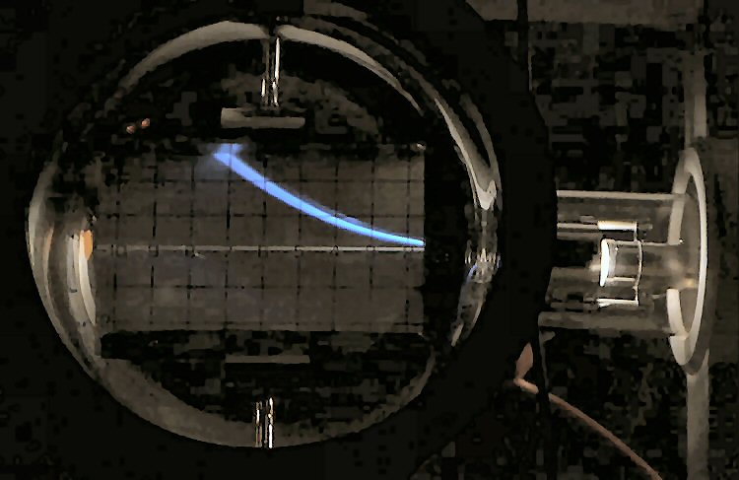

You have
1. Seen electrons in circular motion.
2. Thought about the principles behind this motion.
3. Seen how an accelerating pd can be used to make an electron gun

Practical advice
You will need to set this demonstration up in a well darkened room for maximum effect. You will also want to think carefully about how to display both the tube, in order to explain this action, and the resulting circle, to the size of group that you will be showing it to. It is often a good idea to cover the back of the tube with a black cloth
If new to wiring up electron deflection tubes you may well also wish to practice beforehand, and have a small bench top lamp to hand, well shaded so as not to destroy the dark adaptation of the group’s eyes. You will need to explain and show the actions of the electron gun and the coils, probably using a gimballed bar magnet to show the direction of the field.
You will probably get a spread of circles, perhaps due to the field being non-uniform (a Helmholtz pair only produce an approximately uniform field in the central third of the volume they enclose), due to the electrons provided by the electron gun having a range of velocities, and due to random thermal motion superimposed on the velocity acquired from the action of the accelerating pd.
It may also help to connect both electric deflection plates to the anode in the electron gun and to earth, forcing the filament (cathode) to a large negative voltage.
NB: many low voltage power supplies must not have the output voltage adjusted while delivering high currents.

Safety
Wire carefully, no bare conductor above 40 V
Although the output form the EHT power supply will not give a fatal shock, it can still make the user jump and is quite unpleasant. Teltron tubes often use male 4mm connectors so the leads must terminate in female (socket) connectors if bare conductors are to be avoided.
The protective resistor in the EHT can not be used here.

External references
This activity is taken from Advancing Physics chapter 16, 120D

