TAP 320 - 2: Phase difference and superposition

This question helps you check your understanding of phase difference and gives you further practice in superposing waves.

Graphs of waves

A graph of wave displacement against position shows a wave 'frozen' in space at an instant of time. Really, the waves are travelling along. The graph shows 'snapshots' of two waves, A and B.

1. What is the phase difference between A and B? Give your answers in fractions of a wavelength and degrees. There are at least two correct answers to this question!

2. Sketch the superposition pattern of A and B.

The next diagram shows two more waves, C and D.
3. What is the phase difference between C and D?

4. Sketch the superposition pattern of C and D.

5. What phase angle corresponds to a phase difference of 1/3 of a wavelength?

6. Sketch a diagram showing two waves of equal amplitude with a phase difference equal to 1/3 of a wavelength.

Practical advice
A suitable question to support demonstrations of superposition, phase and path difference.

Answers and worked solutions

1. Zero phase difference

2.

3. One oscillation (or wavelength for a displacement amplitude graph) is equivalent to 360º. Therefore:
$\begin{aligned}1/4 \text{wavelength} = \text{1/4} × \text{360}° = \text{90}° \\ \text{3/4} \text{wavelength} = 3/4 × \text{360}° = \text{270}°\text{.}\end{aligned}$

4.

5. $1/3 × \text{360}° = \text{120}°$

6.
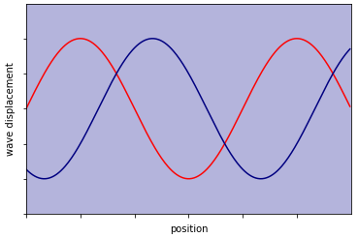

External reference
This activity is taken from Advancing Physics chapter 6, 10W

