TAP 318 - 2: Fibre optics

An important application of total internal reflection is in fibre optics. Light is shone along a thin glass fibre and as it hits the glass-air boundary at more than the critical angle it reflects along inside the fibre. A beam of light travels through a bundle of fibres and as long as the angle of incidence with the walls of a fibre is great enough it will be reflected along the fibre as shown in Figure 1 (the bundles are often called light pipes but you must realize that they are not really a pipe – there is no hollow tube down the centre, each fibre is solid glass). The fibres may be between 0.01 mm and 0.002 mm in diameter and may be arranged at the same relative positions at both ends of the light pipe so that a clear image may be seen through it.
Figure 1

No cladding – multiple reflections at a fairly small angle.
The effect of cladding the fibres with another glass of slightly lower refractive index is shown in the following two diagrams.
Core (n = 1.55)
Cladding (n = 1.45)
Figure 3
Figure 2
The cladding increases the critical angle between the two materials. The benefits of this are:

(a) only those rays that are close to the axis of the fibre pass through
(b) the inner fibre is protected from damage
(c) the rays all travel roughly the same distance and so information fed in at one end arrives at the other only very slightly spread out in time
(d) there are fewer reflections and the distance travelled is smaller than the multiple reflection case and so there is less energy dissipated and the time of transmission is shorter

Critical angle for glass air interface with n = 1.55 = 41.8º

Critical angle between glass (n = 1.55) and glass (n = 1.45) = 69.3º
Uses of fibre optics

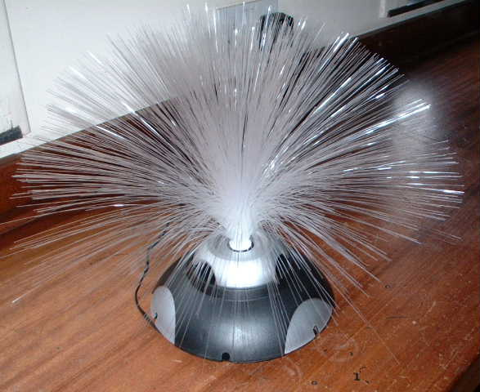
1. Illuminating models or road signs using only one bulb

2. Endoscopy - seeing down inside a patient’s body

3. Communications – sending information along a light beam. Useful for telephone, television, radio, computer networks, stereo links, control in aircraft

4. Security fencing – very difficult to bypass

5. Fibre optic lamp

Advantages of fibre optics over copper wire

1. Cheap – glass is made from silica, the basic constituent of sand

2. Light in weight – useful in aircraft

3. Light beam can carry a huge amount of information

Such fibres can be made to carry information such as TV channels or telephone conversations. Other applications of fibre optics include its use in medicine to see inside the human body and in road signs where one light bulb and a set of fibres is used to illuminate different parts of the sign thus saving fuel need to generate electricity. A further recent application is in security fences. The metal strands of the fence contain a piece of fibre optic material down which a beam of light passes. If the strand is cut the light beam is interrupted and an alarm sounds. It is thought that this type of system is impossible to bypass.

Cladding and multipath dispersion
The fibres are coated with a glass of slightly lower refractive index. This is known as cladding. The cladding increases the critical angle within the core fibre and also prevents adjacent fibres from touching each other. At every point of contact light would escape into another fibre. The fewer the reflections the less energy dissipated, and the shorter the time of transfer of information down the fibre since the light travels a shorter distance.

Initially it would seem that the addition of the cladding would allow light to escape into the surroundings. This is indeed the case but the cladding has another purpose. It means that only the light that makes a small angle with the axis of the fibre is transmitted over large distances. The difference in the time of travel between the individual light rays is therefore smaller and so the spread of information (known as multipath dispersion) is also reduced.
External reference
This activity is taken from Resourceful Physics

