TAP 129- 1: Slow charge and discharge
This activity is intended to give students a ‘slow motion’ view of charging and discharging a capacitor and hence to show the shape of the charge and discharge curves.

Requirements
1000 μF 25 V electrolytic capacitor
100 kΩ 0.6W resistor
clip component holders (2) or crocodile clips (4)
9 V battery or very smooth dc supply
voltmeter f.s.d. 10 V digital
ammeter f.s.d 100 μA (2)
leads

Set-up:
Make the circuit shown below

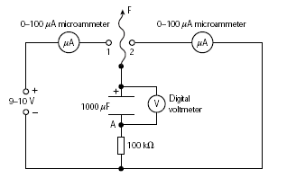

Touch point A with flying lead, F, to make sure that any charge that the capacitor was holding is released, thus discharging the capacitor.
Make sure you can see the voltmeter and ammeters clearly.
Have a table ready to record current and voltage values every 15 seconds.
Connect flying lead, F, to 1. This will begin charging the capacitor through the 100 kΩ resistor.
Carefully monitor what is happening on the meters and note down values every 15 s for around 500 s.
Now connect the flying lead to 2 and, in a similar way, monitor carefully what is happening.

Analysing your results
Sketch or plot graphs of how the following vary as the capacitor charges and discharges:
the current flowing into a capacitor;
the voltage across a capacitor.
Note any similarities and differences between pairs of graphs or all the graphs.
Try to explain the shapes by thinking about electron flow into and out of the capacitor. It may help you to recall a basic rule of electrostatics: ‘like charges repel’.
Use your graphs of the discharge to determine the time for the voltage to fall to 1/2, 1/4 and 1/8 its original value.
Is there a pattern?

External references
This activity is taken from Salters Horners Advanced Physics, A2, Section Transport on Track, TRA, Activity 20

